 | 12.1.34 Editors - Geometry Nodes Editor - Header - Add Menu - Material
Table of content
Detailed table of content 1
Add menu - Material 2
Replace Material 2
Material Index 2
Material Selection 2
Set Material 3
Set Material Index 3

Detailed table of content
Detailed table of content
Detailed table of content 1
Add menu - Material 2
Replace Material 2
Inputs 2
Geometry 2
Old 2
New 2
Outputs 2
Geometry 2
Material Index 2
Output 2
Material Index 2
Material Selection 2
Inputs 3
Material 3
Outputs 3
Geometry 3
Set Material 3
Inputs 3
Geometry 3
Selection 3
Material 3
Output 3
Geometry 3
Set Material Index 3
Inputs 3
Geometry 3
Selection 3
Material Index 4
Output 4
Geometry 4

Add menu - Material
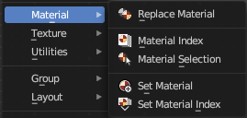
Nodes to modify the material.

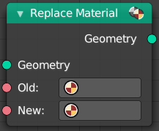
Replace Material
Replace an existing material by a new material.

Inputs

Geometry
The geometry that you want to assign the material to.

Old
The old material.

New
The new material.

Outputs

Geometry
Standard geometry output.

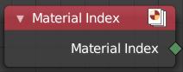
Material Index
Retreives the material index.

Output

Material Index
The material index.

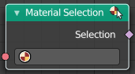
Material Selection
Select geometry by Material.
Since the material index is stored on each face, the output will be implicitly interpolated to a different element when necessary. For example, every vertex connected to a selected face will be selected.

Inputs

Material
The material.

Outputs

Geometry
Standard geometry output.

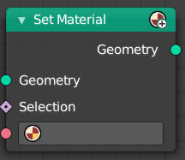
Set Material
Assign a material to a mesh or a selection of a mesh.

Inputs

Geometry
The geometry that you want to assign the material to.

Selection
The selection that you want to assign the material to.

Material
The material that you want to assign.

Output

Geometry
Standard geometry output.

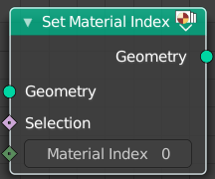
Set Material Index
Assing a material index to a mesh or a selection of a mesh.

Inputs

Geometry
The geometry that you want to assign the material to.

Selection
The selection that you want to assign the material to.

Material Index
The material index that you want to assign.

Output

Geometry
Standard geometry output.

